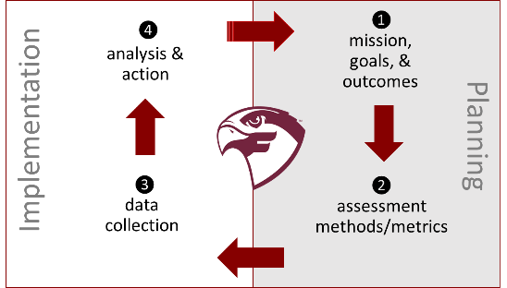

Assessment for 2019 Cycle

❶

mission, goals, & outcomes

Unit/Degree Program: <insert unit name>

Mission: <insert unit mission>

*As part of the (higher level) mission of* Unit/Division: <insert next level up organizational mission>

Goals:

1. <insert Goal 1>
2. <insert Goal 2>
3. <insert Goal 3>

Outcomes:

1. <insert outcome associated with at least one goal>
2. <insert outcome associated with at least one goal>
3. <insert outcome associated with at least one goal>
4. <insert outcome associated with at least one goal>
5. <insert outcome associated with at least one goal>

Program Curriculum Map:

|  |  |  |  |  |  |  |
| --- | --- | --- | --- | --- | --- | --- |
| Course | Outcome 1 | Outcome 2 | Outcome 3 | Outcome 4 | Outcome 5 | Outcome 6 |
|  |  |  |  |  |  |  |
|  |  |  |  |  |  |  |
|  |  |  |  |  |  |  |
|  |  |  |  |  |  |  |
|  |  |  |  |  |  |  |
|  |  |  |  |  |  |  |
|  |  |  |  |  |  |  |

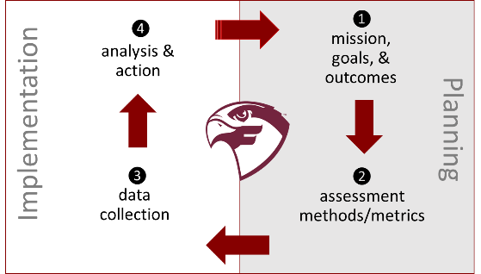

❷

assessment methods/metrics

Overall assessment strategy: <insert ~ one(1) paragraph of narrative>

Methods and Metrics: <insert approach (mapped to outcomes) above in table>

|  |  |  |  |
| --- | --- | --- | --- |
| Outcome | Measurement | Method(s) | Metric/Measurement(s) |
| 1) | 1)-1 |  |  |
| 2) | 2)-1 |  |  |
| 3) | 3)-1 |  |  |
| 4) | 4)-1 |  |  |
| 5) | 5)-1 |  |  |
|  |  |  |  |
|  |  |  |  |

❸

data collection

|  |  |  |
| --- | --- | --- |
| Outcome | Measurement | [Link to] Data Collected |
| 1) | 1)-1 |  |
| 2) | 2)-1 |  |
| 3) | 3)-1 |  |
| 4) | 4)-1 |  |
| 5) | 5)-1 |  |
|  |  |  |
|  |  |  |



❹

analysis & action

|  |  |  |
| --- | --- | --- |
| Outcome | Measurement | Reflection on Data Collected |
| 1) | 1)-1 |  |
| 2) | 2)-1 |  |
| 3) | 3)-1 |  |
| 4) | 4)-1 |  |
| 5) | 5)-1 |  |
|  |  |  |
|  |  |  |

Additional Perspective on Data, Methods, and Process: <insert ~ 1-2 paragraphs of narrative>

Conclusions and Recommended Actions: <insert ~ one(1) paragraph of narrative and specific actions>

* Action 1:
* Action 2:
* Action 3:



Assessment Cycle Acknowledgments

|  |  |
| --- | --- |
| Team Member(s) Acknowledgement | Date |
|  |  |
|  |  |
|  |  |
|  |  |
|  |  |
|  |  |

Department Chair Comments:

|  |  |
| --- | --- |
| Department Chair’s Acknowledgement | Date |
|  |  |

Dean Comments:

|  |  |
| --- | --- |
| Dean’s Acknowledgement | Date |
|  |  |

Assessment Ambassador(s) Comments:

|  |  |
| --- | --- |
| Assessment Ambassador’s Acknowledgement | Date |
|  |  |